Test preparation HW #2: Solution
1. A box of mass $M$ is on a rough incline that makes an angle $θ$ with the horizontal. The coefficient of kinetic friction between the box and the incline is $μ$. The box is placed against a spring whose other end is secured to a wall at the lower end of the incline. The block is used to compress the spring a distance $D$ and is then released from rest.
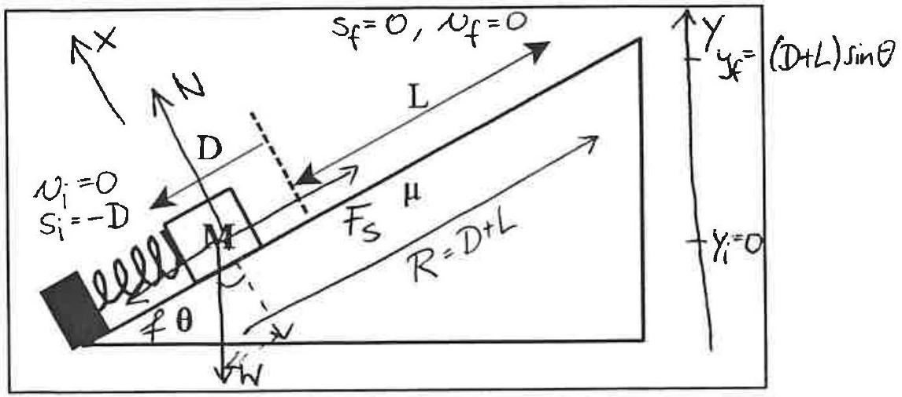
Complete the diagram with all information necessary to solve Part b) below. Remember, any algebraic quantity that you use must appear in the diagram. You may want to add elements as you go along.
In terms of relevant system parameters, derive an expression for the minimum spring constant $k$ necessary to ensure that the box reaches a distance $L$ up the incline from the equilibrium position of the spring. (Treat the box as a point mass.)
$$\begin{matrix} & E_{f}-E_{i}=W_{other} \\ & \frac{M}{2}v_{f}^{2}+Mgy_{f}+\frac{1}{2}kx_{f}^{2}-\left(\frac{M}{2}{v_{i}^{2}}_{2}+Mgy_{i}+\frac{1}{2}kx_{i}^{2}\right)=W_{N}+W_{fr} \\ & Mg(D+L)sin⁡θ-\frac{1}{2}k(-D)^{2}=\vec{f}⋅\vec{R}=-(μN)(D+L) \\ & \text{to find} N: \sum{ }F_{x}=N_{x}+W_{x}+f_{x}+F_{sx}=Ma_{x} \\ & N+(-Mgcos⁡θ)=0 \\ & N=Mgcos⁡θ \\ & Mg(D+L)sin⁡θ-\frac{1}{2}kD^{2}=-μMgcos⁡θ(D+L) \\ & \frac{1}{2}kD^{2}=Mg(D+L)sin⁡θ+μMg(D+L)cos⁡θ \\ & k=\frac{2Mg(D+L)[sin⁡θ+μcos⁡θ]}{D^{2}}\end{matrix}$$

2. A projectile of mass $m$ is shot directly away from the surface of a planet of mass $M$ and radius $R$ with an initial speed that equals $\frac{1}{2}$ the escape speed from the planet. Derive an expression for the maximum distance from the center of the planet the projectile reaches, in terms of $R$.
- Find escape speed:
$$\begin{matrix}E_{f}-E_{i} & =W_{\text{other} } \\ E_{i} & =E_{f} \\ \frac{1}{2}mv_{esc}^{2} & -\frac{GMm}{\frac{R}{2}}=\frac{1}{2}mv_{f}^{2}-\frac{GMm}{r_{f}} \\ v_{esc} & =\sqrt{\frac{2GM}{R}}\end{matrix}$$

2. Launch will $1/2$ V_{esc}:
$$\begin{matrix}E_{f}-E_{i}= \text{Wother} \\ E_{i}=E_{f} \\ \frac{1}{2}m{\left(\frac{1}{2}\sqrt{\frac{2GM}{R}}\right)}^{2}-\frac{GMm}{R}=-\frac{GMm}{x} \\ \frac{1}{4}\frac{GMm}{R}-\frac{GMm}{R}=-\frac{GMm}{X} ⟶x=\frac{4}{3}R\end{matrix}$$
b) A satellite of mass $m$ is put into a circular orbit around the planet of mass $M$ and radius $R$. It orbits a distance $2R$ above the planet's surface. Derive an expression for total mechanical energy $E$ of the satellite, in terms of $G,m,M$ and $R$.
$$E=K+U=\frac{1}{2}mv^{2}-\frac{GMm}{3R}$$
Find v: $\sum{ }F_{x}=F_{G}=ma_{x}$
$$\begin{matrix}\frac{GMm}{(3R)^{2}} & =m\frac{v^{2}}{3R} \\ v^{2} & =\frac{GM}{3R}\end{matrix}$$

$$\begin{matrix} & E=\frac{1}{2}m\frac{GM}{3R}-\frac{GMm}{3R} \\ & E=-\frac{GMm}{6R}\end{matrix}$$
2. A firecracker of mass 4M is moving with speed V at an angle θ with the positive x-direction as shown in the figure and explodes. Immediately after the explosion, fragment 1 of mass 2M is moving with speed ½V in the positive y-direction. Fragment 2 of mass M continues with speed V in the positive x- direction. The third fragment moves at unknown speed V₃ in an unknown direction.
V
2M
M

M
V
½V
V₃?
Before
After
x
y
4M
θ

In terms of system parameters, derive an expression for the velocity vector of the third fragment, in unit vector notation.

${\vec{J}}_{net ext}$ $={\vec{P}}_{f}-{\vec{P}}_{i}=0, {\vec{P}}_{f}={\vec{P}}_{i}$
$$P_{ix}=P_{fx}$$
$$4MV\cos{} =0+MV+MV_{3x}$$
$$V_{3x}=V\left(4\cos{}-1\right)$$
$$P_{iy}=P_{fy}$$
$$4MV\sin{}=2M\frac{V}{2}+0+MV_{3y}$$
$$V_{3y}=V(4\sin{ }-1)$$

$$\vec{V_{3}}= V\left(4\cos{}-1\right)\hat{i}+V(4\sin{ }-1)\hat{j}$$

